Tables and Figures.

Figure 1. Manifold used for the on-line SPE in combination with HPLC-UV equipment for the determination of 2,4-D and atrazine in corn samples. S1: syringe, HC: holding coil, MPV: multi-position valve, SPE: solid phase extraction, IV: injection valve, MP: mobile phase, MC: monolithic column.

Figure 2. The effect of (a) the sorbent amount, (b) methanol content in the eluent and (c) sample loading volume on the normalized peak height intensity. (Conditions: herbicides concentration; 1 mg L⁻¹, eluent; 0.5 mL and flow rate; 1 mL min⁻¹).

Figure 3. The effect of (a) solvent, (b) time and (c) temperature on extraction recoveries of herbicides by MAE procedure.

Figure 1.

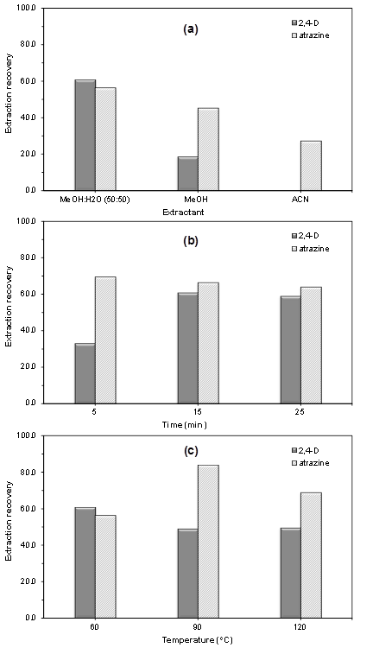

Figure 2.

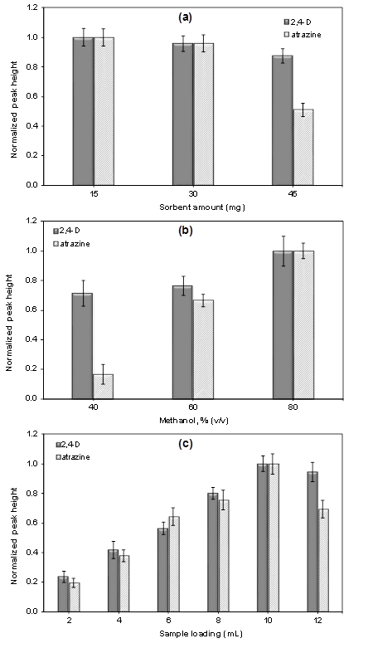

Figure 3.

