Dr. Katarzyna Dorota Wrobel
Editor of the Special Issue from the Journal of the Mexican Chemical Society
Chemistry Department,
Universidad de Guanajuato, México.
Telephone: +52 473 7327555
Email: katarzyn@ugto.mx

Monterrey, Mexico, January 30, 2018

Dear Dr. Wrobel,

I am pleased to submit the paper entitled “Atrazine and 2, 4-D determination in corn samples using microwave assisted extraction and on-line solid-phase extraction coupled to liquid chromatography” for publication in the Journal of the Mexican Chemical Society to the special issue “Modern Analytical Chemistry in Interdisciplinary Research” with Katarzyna Wröbel as a guest editor. The authors of the manuscript are: A.S. Santos-Hernández, L. Hinojosa-Reyes, I.C. Sáenz-Tavera, A. Hernández-Ramírez and J.L. Guzmán-Mar.

This manuscript described a on-line sample pretreatment (clean-up and analyte preconcentration) coupled to sequential injection chromatography for the determination of 2, 4-D (2,4-dichlorophenoxyacetic acid) and atrazine in corn samples. Prior to their analysis, microwave-assisted approach was evaluated and optimized for the extraction of 2,4-D and atrazine in corn samples. Extraction was carried out using MeOH:water (30:70 v/v) solvent at 50°C for 15 min. The on-line SPE-HPLC/UV approach combined reversed solid-phase extraction using strata X sorbent with MeOH:H₂O (80:20 v/v) at 1 mL min⁻¹ as eluent for the enrichment of the analytes. C18 monolithic column with acetonitrile:10 mM acetate buffer pH 4 (20:80, v/v) was employed as mobile phase at 2 mL min⁻¹ flow rate for separation of the compounds before UV detection. Enrichment factors up to 13.4 were achieved with a 10 mL sample volume. The developed procedure showed linear response ranges from 0.07–0.70 mg kg⁻¹ for 2,4-D and atrazine with correlation coefficients >0.993. The LODs were 0.03 and 0.02 mg kg⁻¹ for 2,4-D and atrazine, respectively with RSD ranged from 4.0 to 7.2% at 0.07 and 0.30 mg kg⁻¹. The recoveries of 2,4-D and atrazine in corn samples were from 82.6 and 98.2%. The proposed method showed good recoveries and reasonable precision for herbicide analysis in corn samples avoiding the time-consuming batch sample pretreatment step, thus minimizing risks of sample contamination and analyte losses.

We suggest the following reviewers for the manuscript:

Dra. Luz Leal Quezada
Centro de Investigaciones en Materiales Avanzados S.C.
CIMAV, CONACYT.
Phone: +52(614)4394810
e-mail: luz.leal@cimav.edu.mx

Dra. Laura Daniela Ferrer Trovato
University of the Balearic Islands
Faculty of Sciences, Department of Chemistry
Phone: 971173260
e-mail: laura.ferrer@uib.es

Dra. Judith Amador Hernández
Universidad Autónoma de Coahuila
Facultad de Ciencias Químicas,
e-mail: amadorjudith@live.com.mx

Thank you very much in advance for your kind consideration of our work.
Sincerely yours,

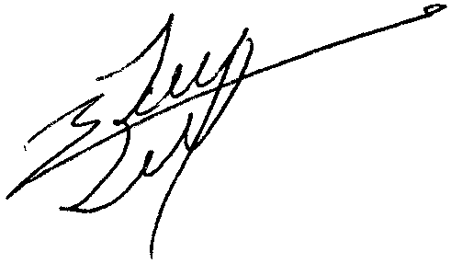

Dr. Jorge Luis Guzman Mar
Universidad Autónoma de Nuevo León
Department of Chemistry Sciences
Av. Guerrero s/n Eq. con Progreso, Col. Treviño
Monterrey N.L.CP 64570. México
Tel: (81) 83-29-4000 Ext. 3424
e-mail: jorge.guzmanmr@uanl.edu.mx

