Supplementary Information
Synthesis, characterization and cytotoxic activity of tioconazole coordination compounds with nickel(II), palladium(II) and platinum(II)

Carmela Crisóstomo-Lucas¹, Rubí Navarro-Peñaloza¹, Naytzé Ortiz-Pastrana^{1,2}, Francisco Sánchez-Bartéz^{1,3}, Isabel Gracia-Mora^{1,3}, Norah Barba-Behrens^{1*}

¹Departamento de Química Inorgánica, Facultad de Química, Universidad Nacional Autónoma de México, Ciudad Universitaria, Coyoacán, 04510, Ciudad de México, México.
²Departamento de Química, Cinvestav, AP 14-740, 07000, Ciudad de México, México
³Unidad de Investigación Preclínica (UNIPREC), Facultad de Química, Universidad Nacional Autónoma de México, Ciudad de México, México

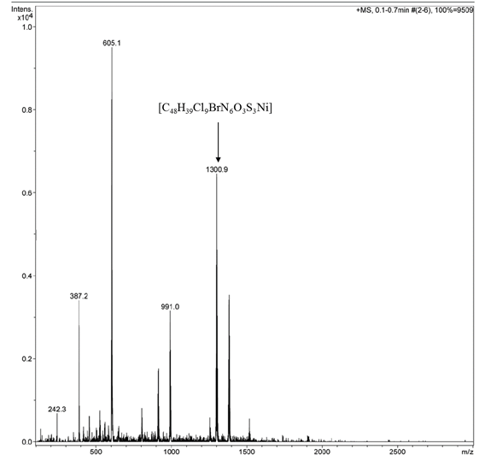

Figure S1. MS-ESI⁺ spectrum of [Ni(tcnz)₃Br₂(H₂O)] 1.

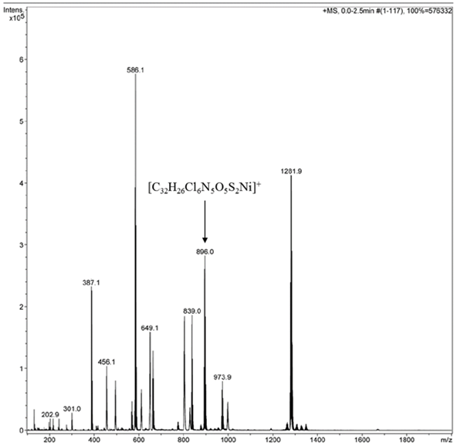

Figure S2. MS-ESI⁺ spectrum of [Ni(tcnz)₂(NO₃)₂]∙H₂O 2.

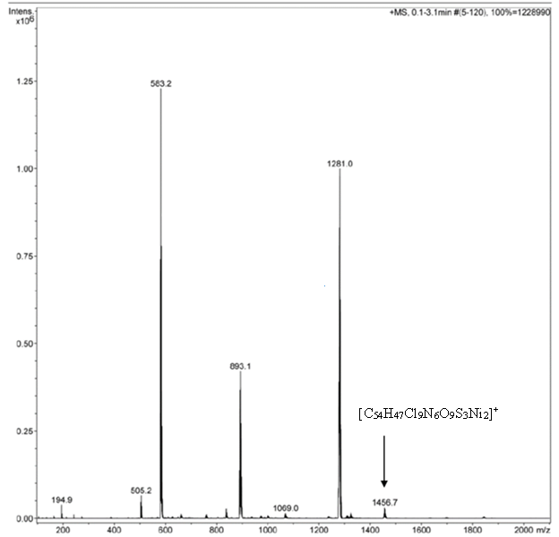
Figure S3. MS-ESI⁺ spectrum [Ni(tcnz)₂(OAc)₂]∙3H₂O 3.

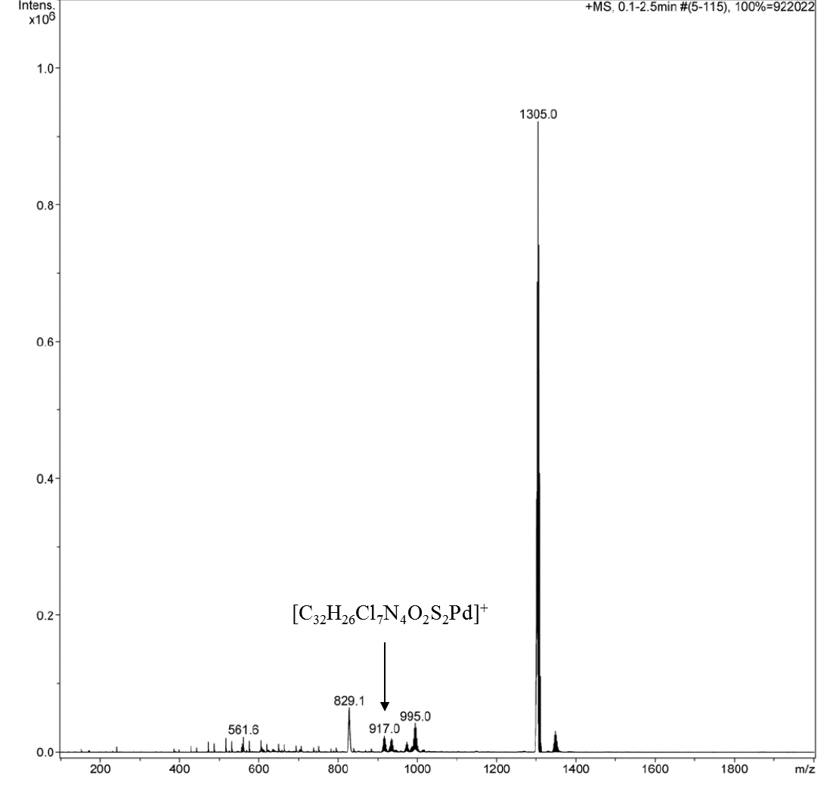

Figure S4. MS-ESI⁺ spectrum of [Pd(tcnz)₂Cl₂] 6.

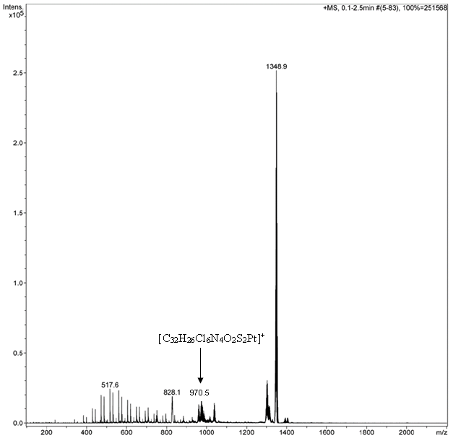
Figure S5. MS-ESI⁺ spectrum of [Pt(tcnz)₂Cl₂]∙2H₂O 7.

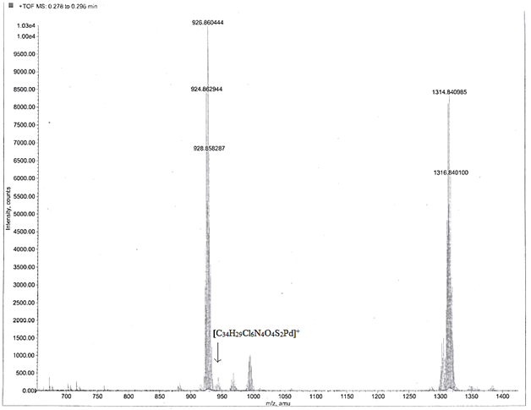
Figure S6. MS-TOF⁺ spectrum of [Pd(tcnz)₂(OAc)₂] 8.

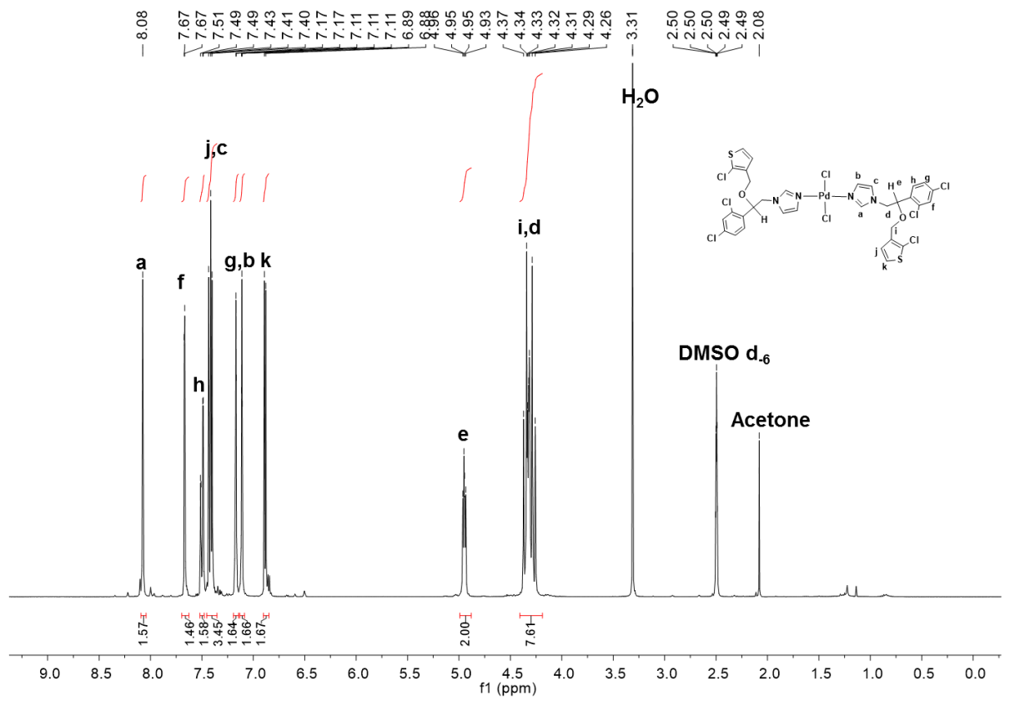
Figure S7. ¹H NMR spectrum of [Pd(tcnz)₂Cl₂] 6 in DMSO–d₆.
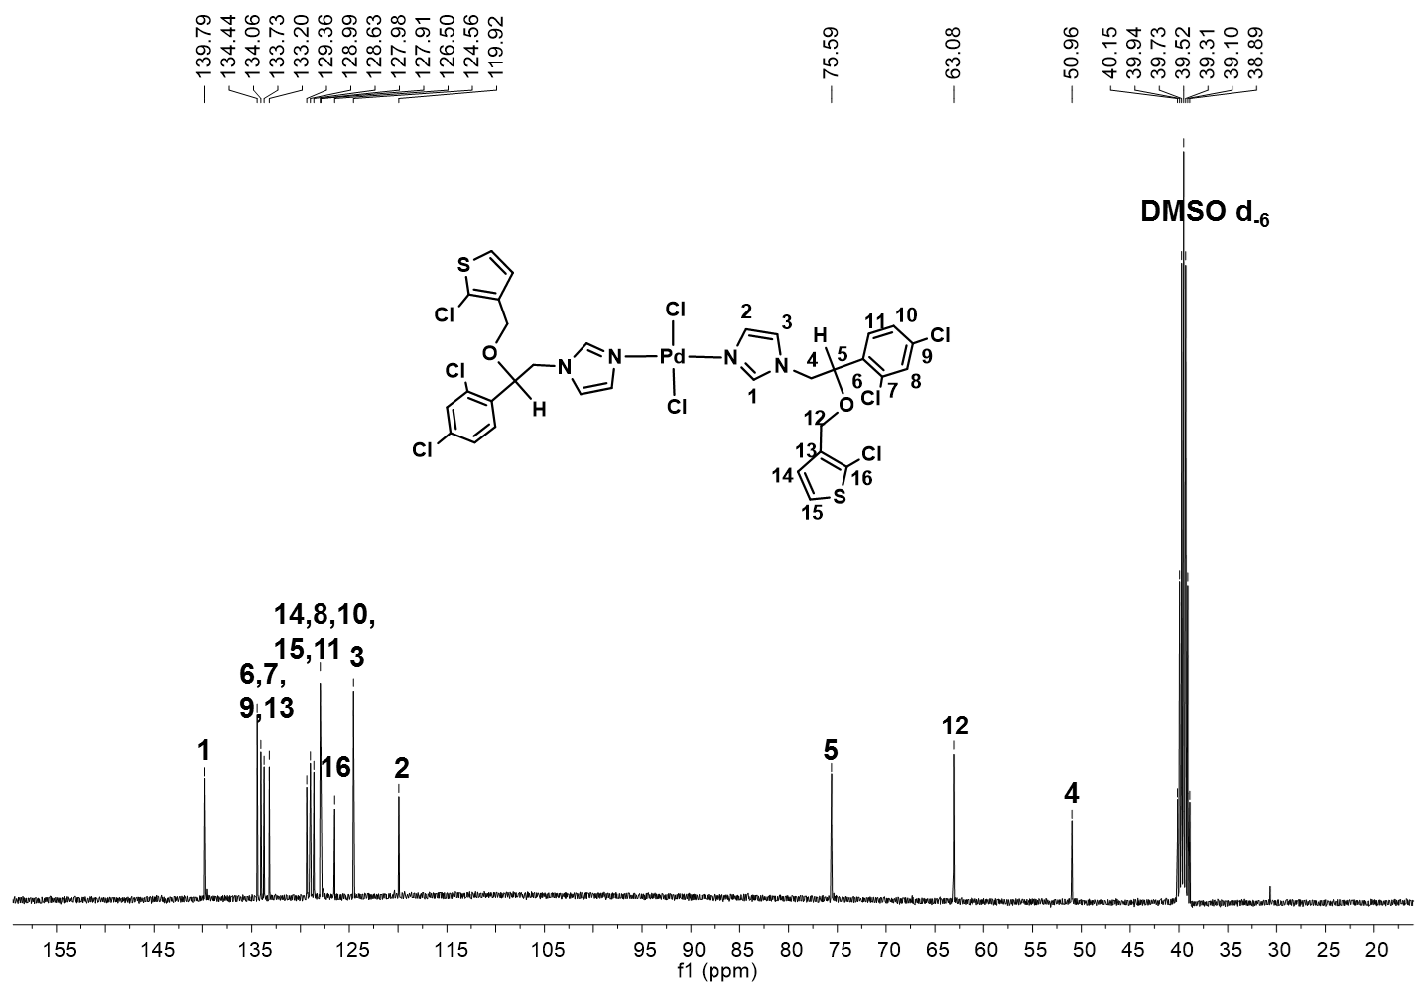
Figure S8. ¹³C {¹H} NMR spectrum of [Pd(tcnz)₂Cl₂] 6 in DMSO–d₆.

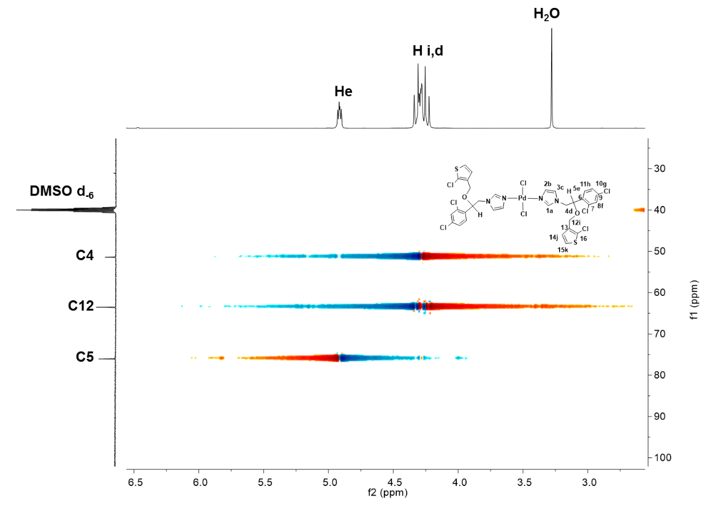
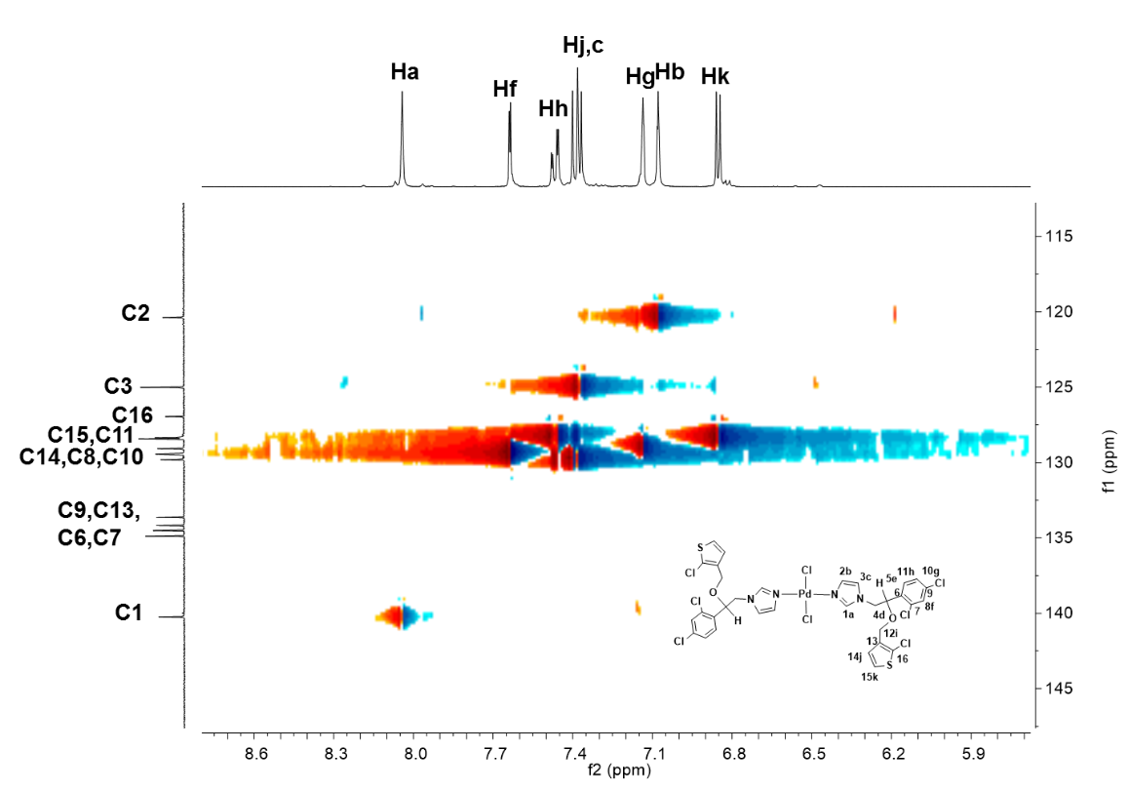
Figure S9. HSQC NMR spectra of [Pd(tcnz)₂Cl₂] 6 in DMSO–d₆.

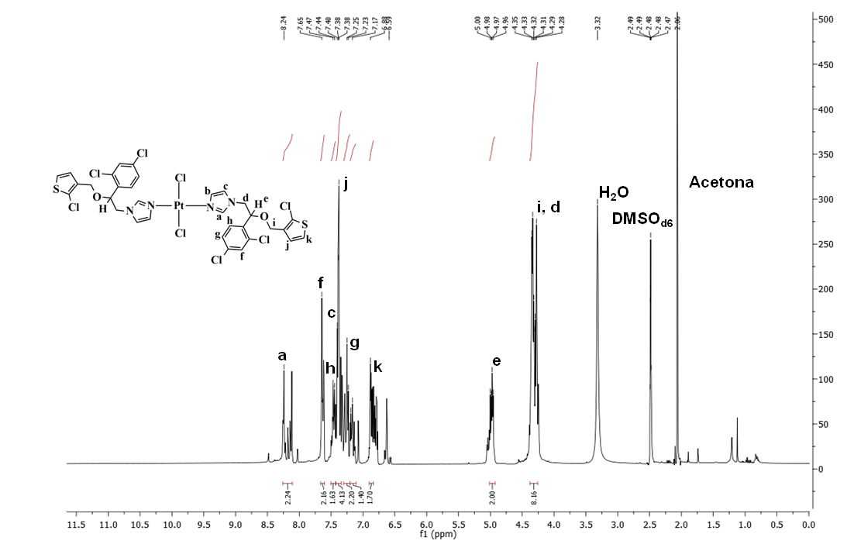
Figure S10. ¹H NMR spectrum of [Pt(tcnz)₂Cl₂] 7 in CDCl₃.
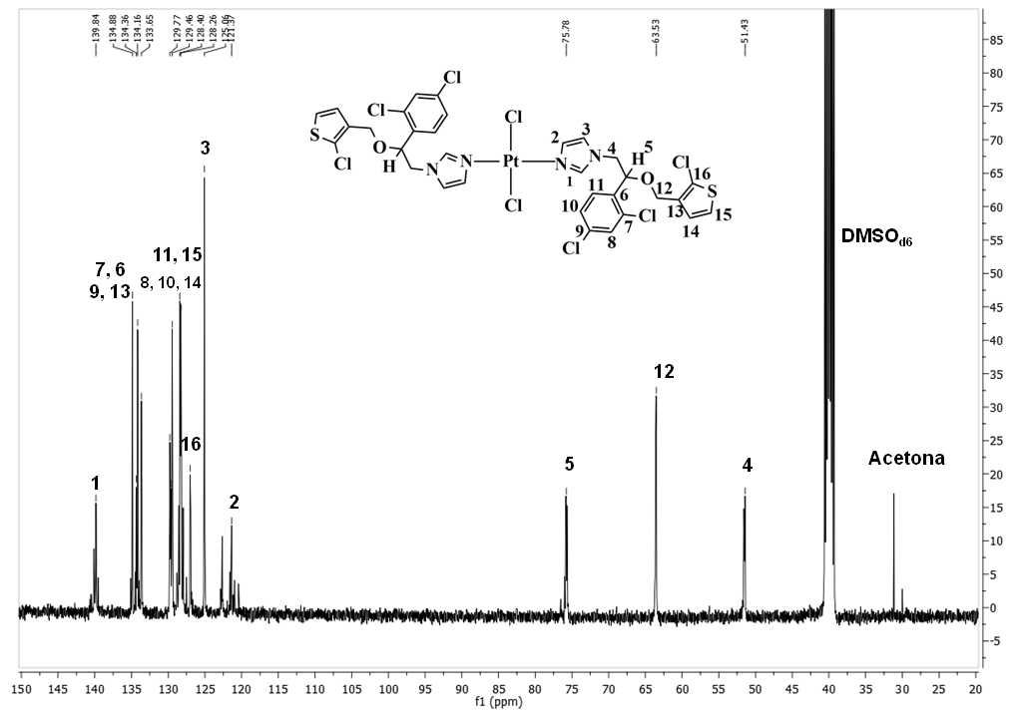
Figure S11. ¹³C {¹H} NMR spectrum of [Pt(tcnz)₂Cl₂] 7 in CDCl₃.
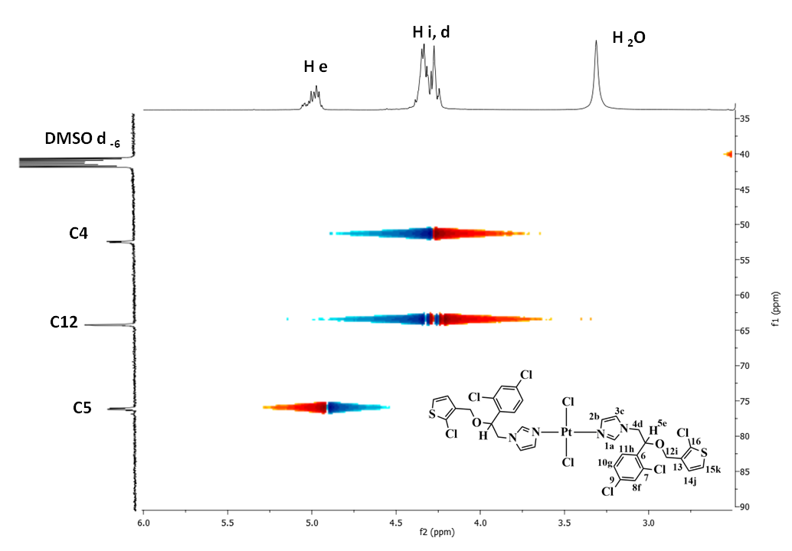
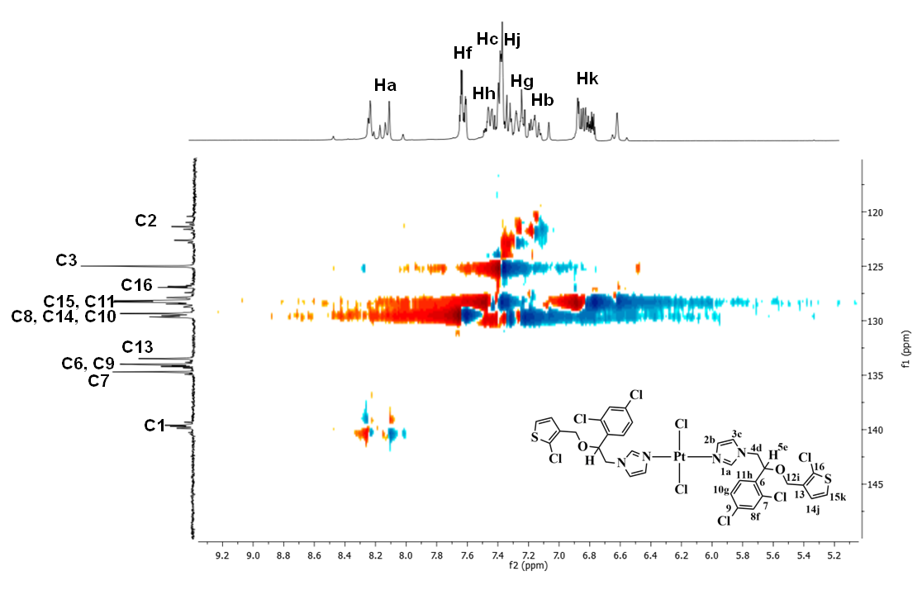
Figure S12. HSQC NMR spectra of [Pt(tcnz)₂Cl₂] 7 in CDCl₃.

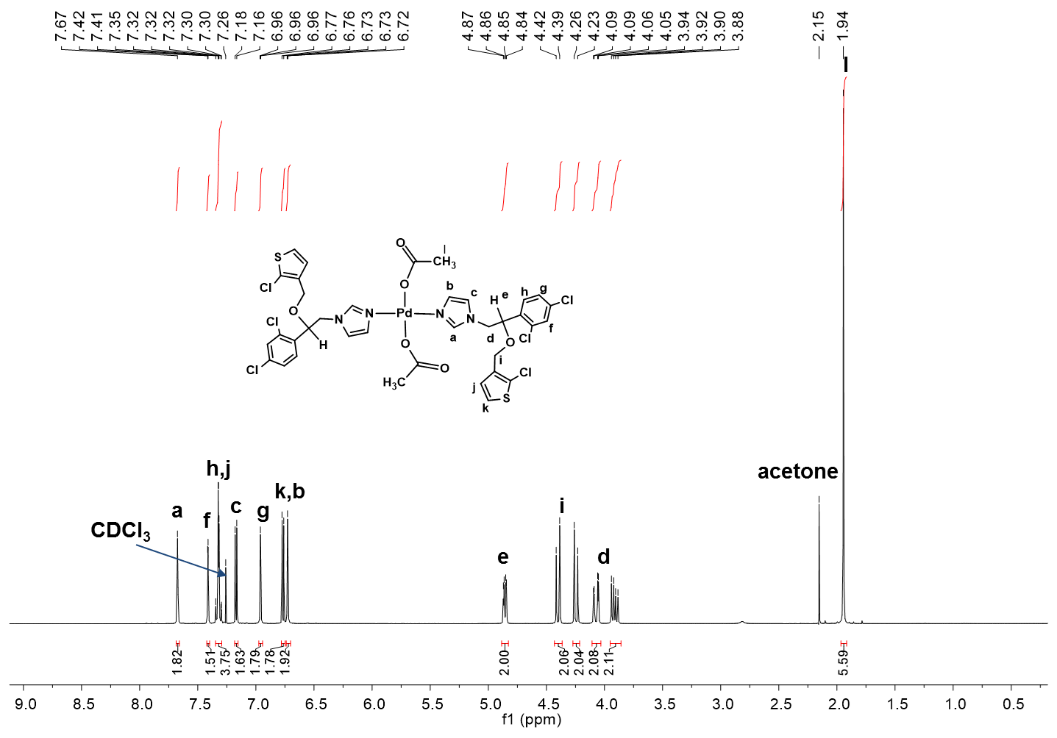
Figure S13. ¹H NMR spectrum of [Pd(tcnz)₂(OAc)₂] 8 in CDCl₃.
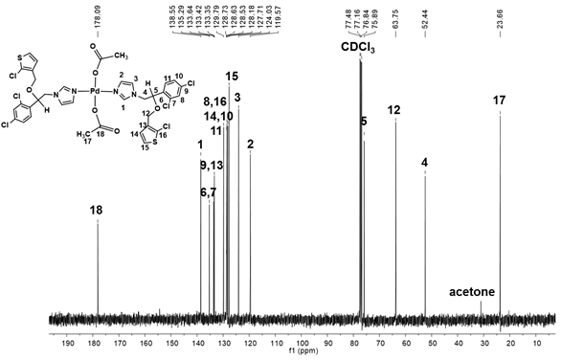
Figure S14. ¹³C {¹H} NMR spectrum of [Pd(tcnz)₂(OAc)₂] 8 in CDCl₃.
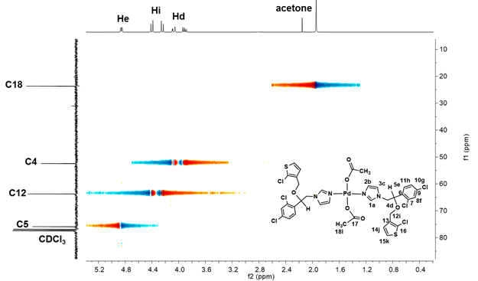
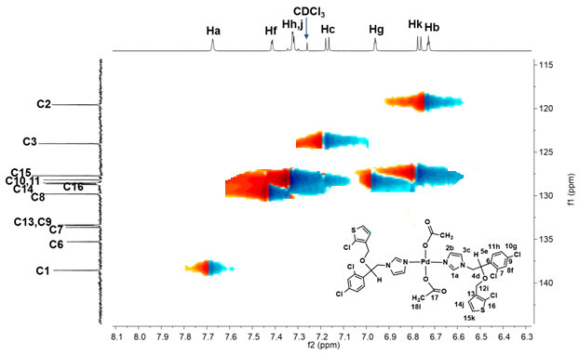
Figure S15. HSQC NMR spectra of [Pd(tcnz)₂(OAc)₂] 8 in CDCl₃.

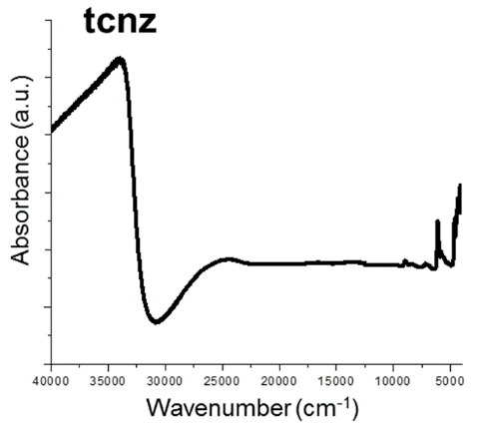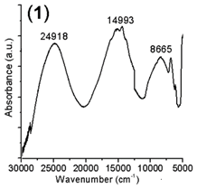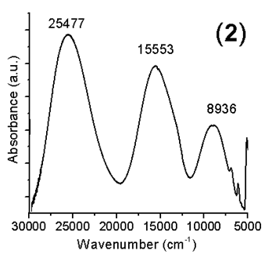

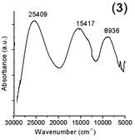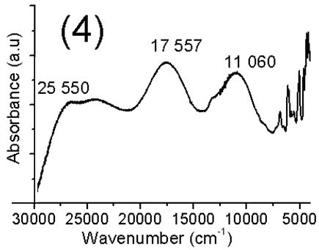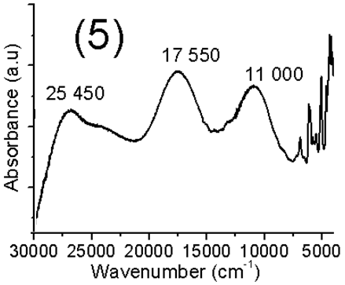

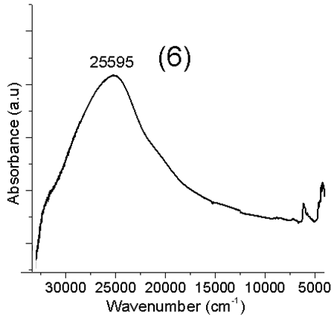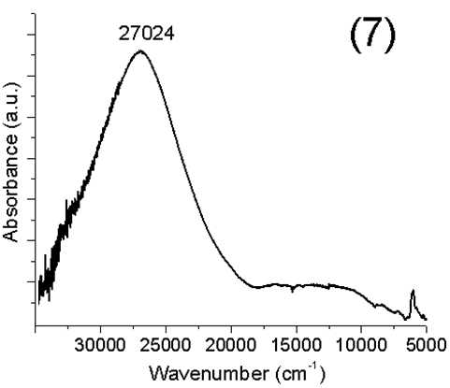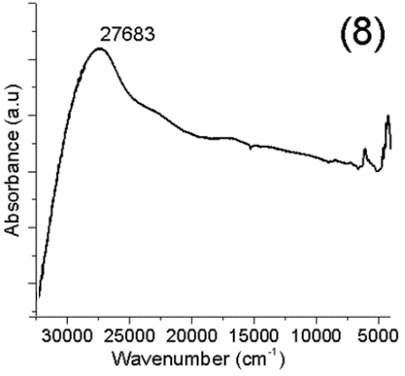
Figure S16. Solid state UV-Vis-NIR ν(cm⁻¹) of tioconazole compounds of
Ni^{II}, Pd^{II} and Pt^{II}.

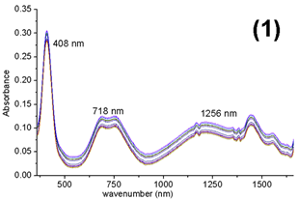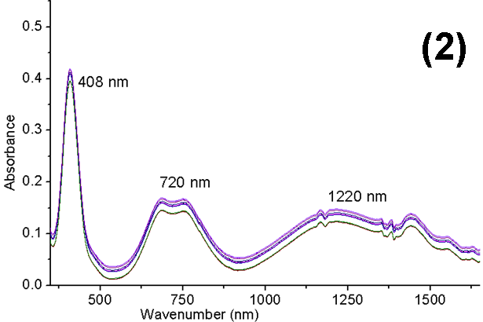
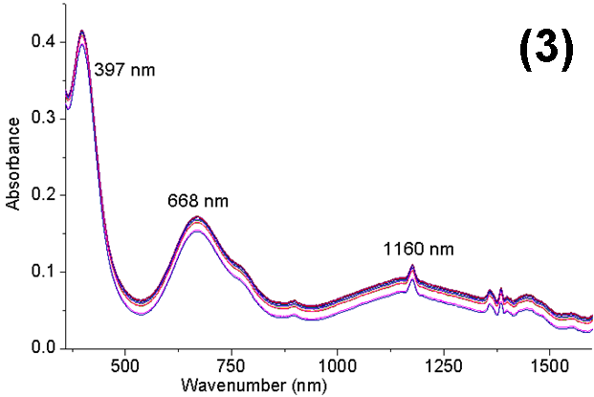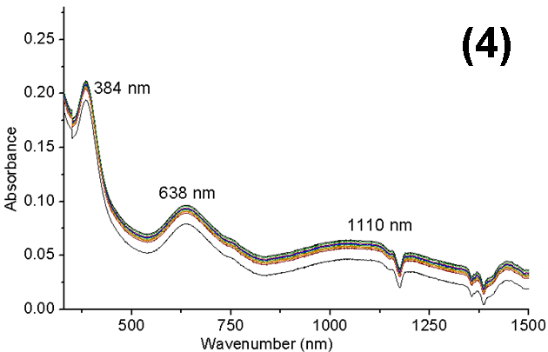
Figure S17. UV-Vis-NIR ν(cm⁻¹) of Ni^{II} tioconazole compounds in DMSO solution, 0-24 h.

